# **Passing and returning values using pointers**

## **Function pointers**

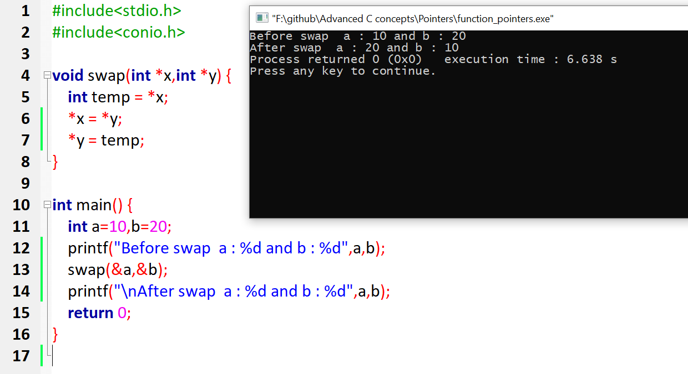

1)

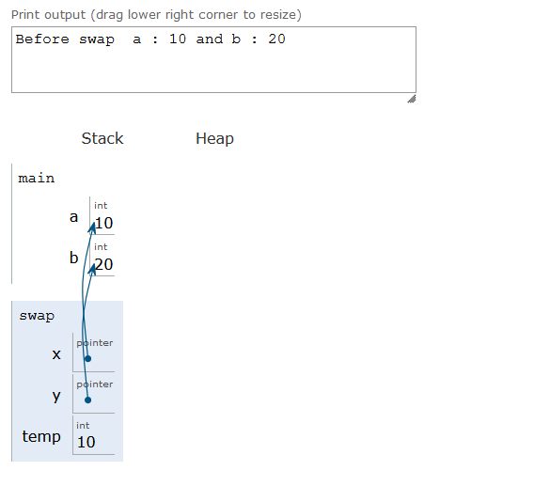

2)

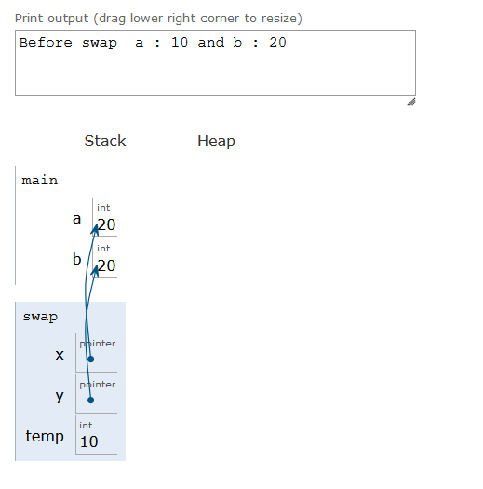

3)

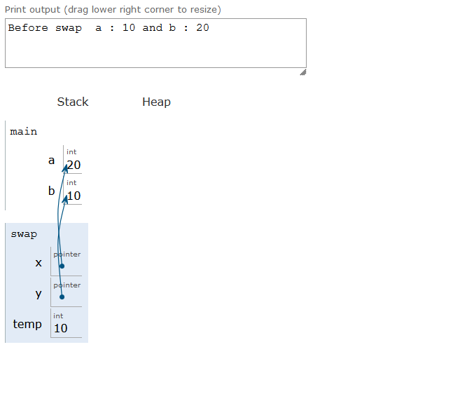

4)

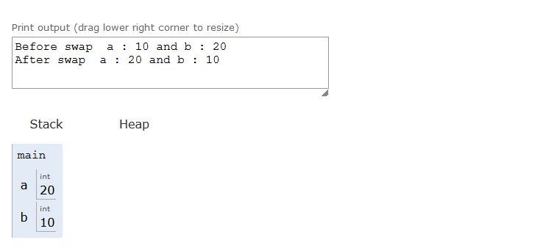

## **Function with Array Parameters**

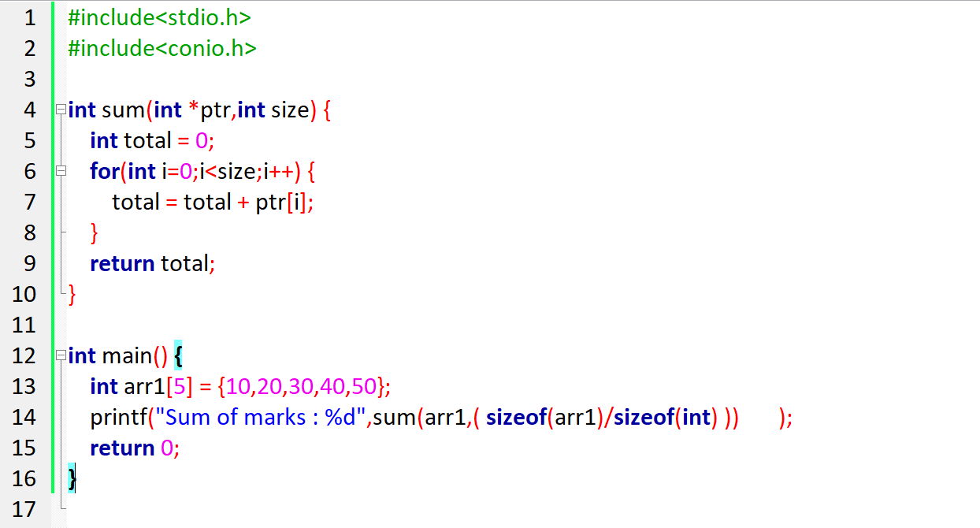

## **Function that returns an Array**

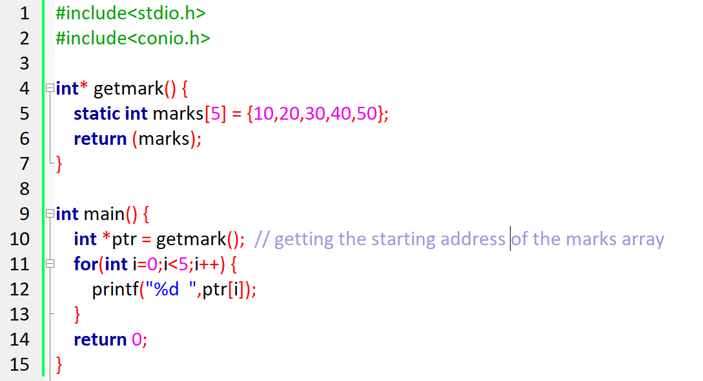

## **Function returning pointer**

### Without static

### With static

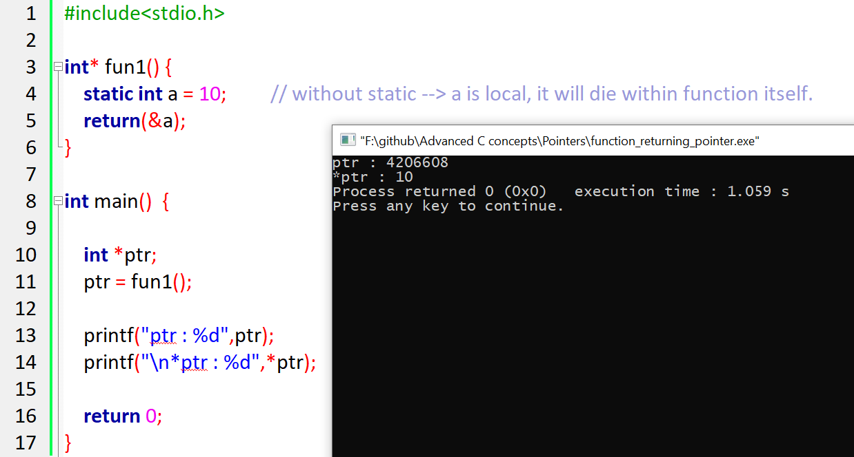

# **Difference between static and global variables**

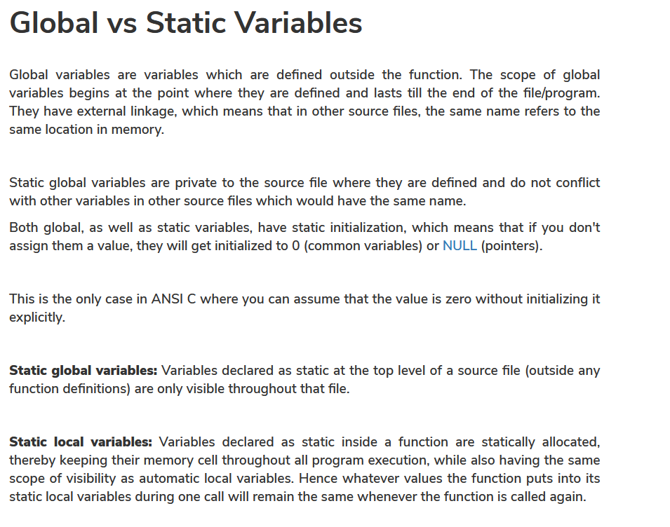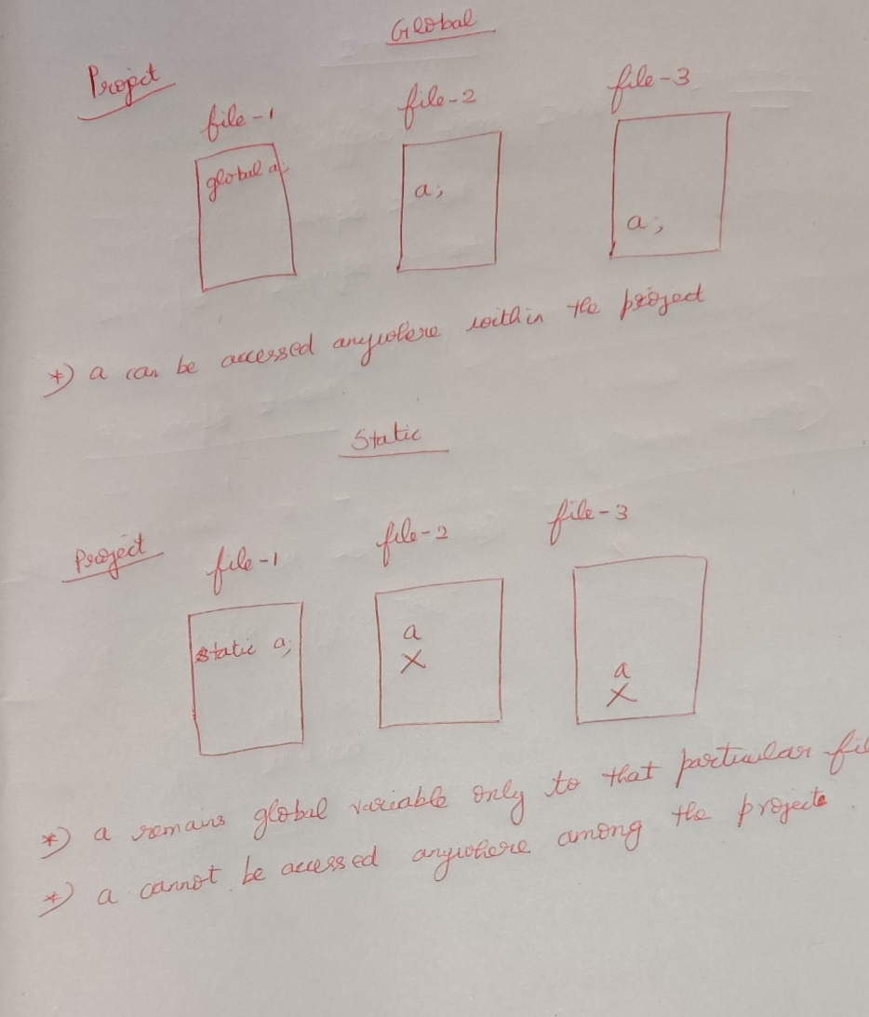

## **Function returning pointer variables**

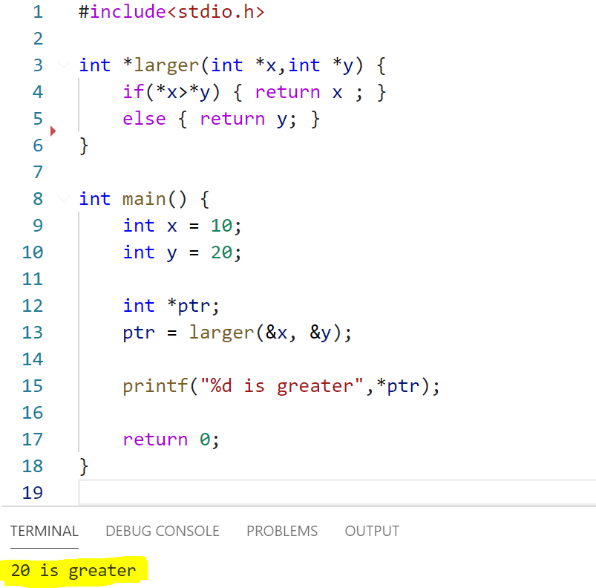

**int* fun1(int a, int b)** 🡪 a function returning a pointer value.

# **Pointer to a function**

**int (*fun1) (int a, int b)** 🡪 pointer to a function.

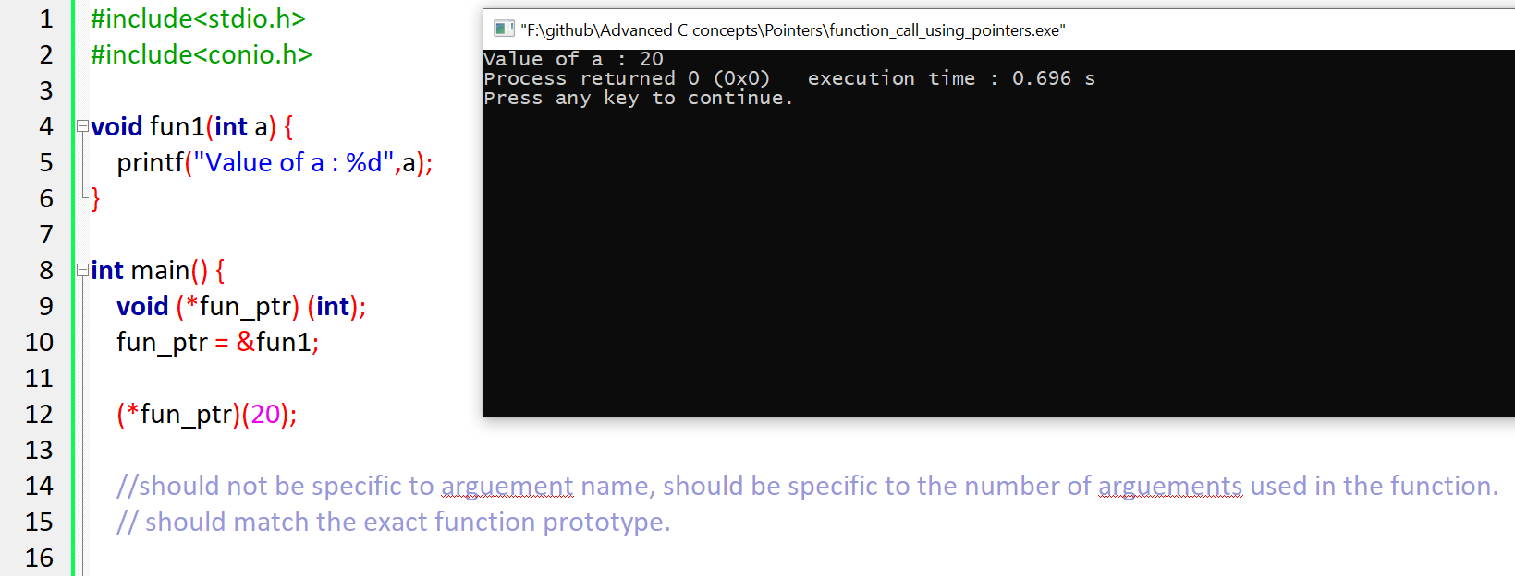

Illustrate how the function pointer can be changed to point to different functions during the program execution.

## **Pointer to different function**

Refer pointer_to_different_function.c

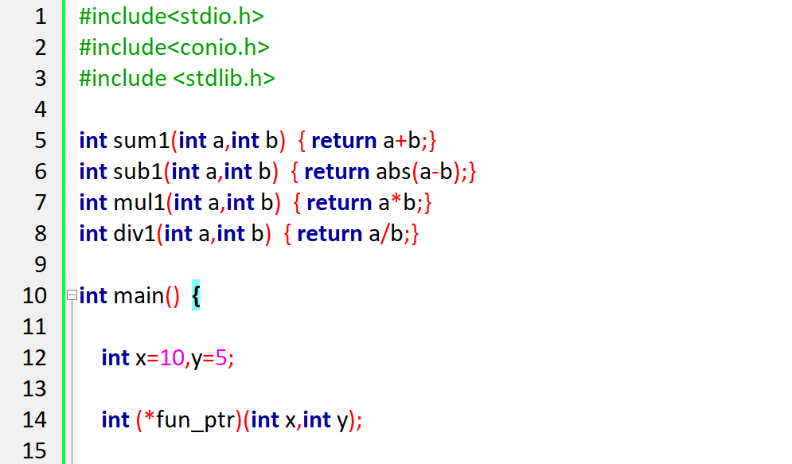  
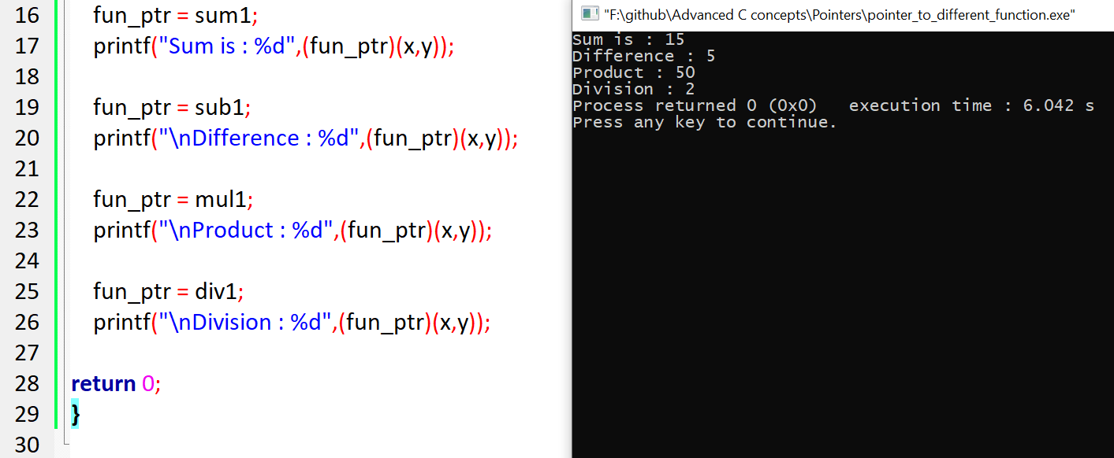

The same can be implemented with **array of pointers** also.

## **Pointer to different function (with array)**

Refer to pointer_to_different_function(array_of_pointers).c

Method-1 (Array of pointers)

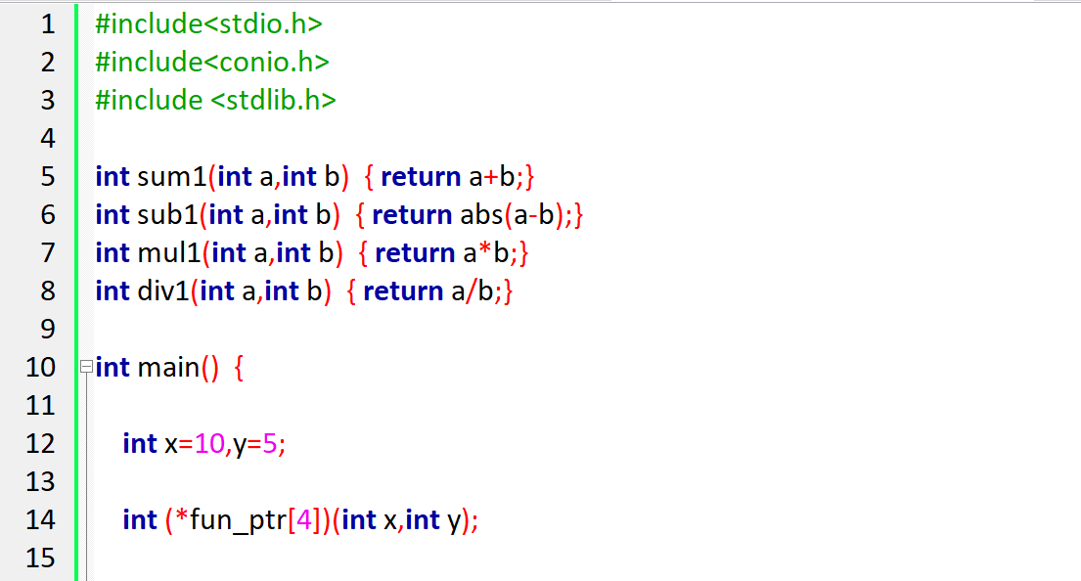 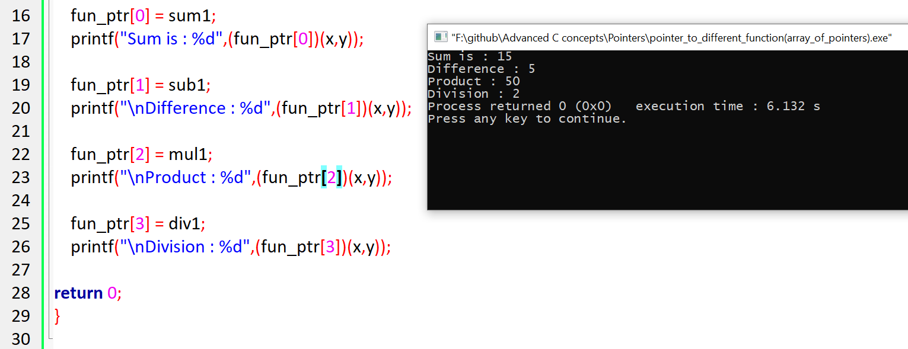

Method-2 (Array of function pointers)

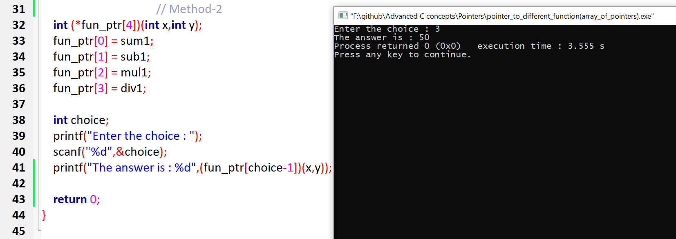

# **Passing a Function pointer as an argument to a function**

This is nested function pointer (i.e function pointer within function pointer)

Refer function_pointer_as_arguements.c

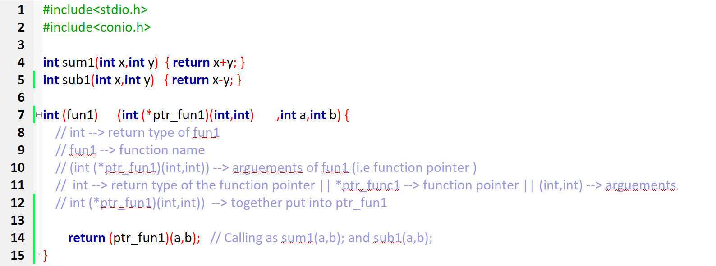  
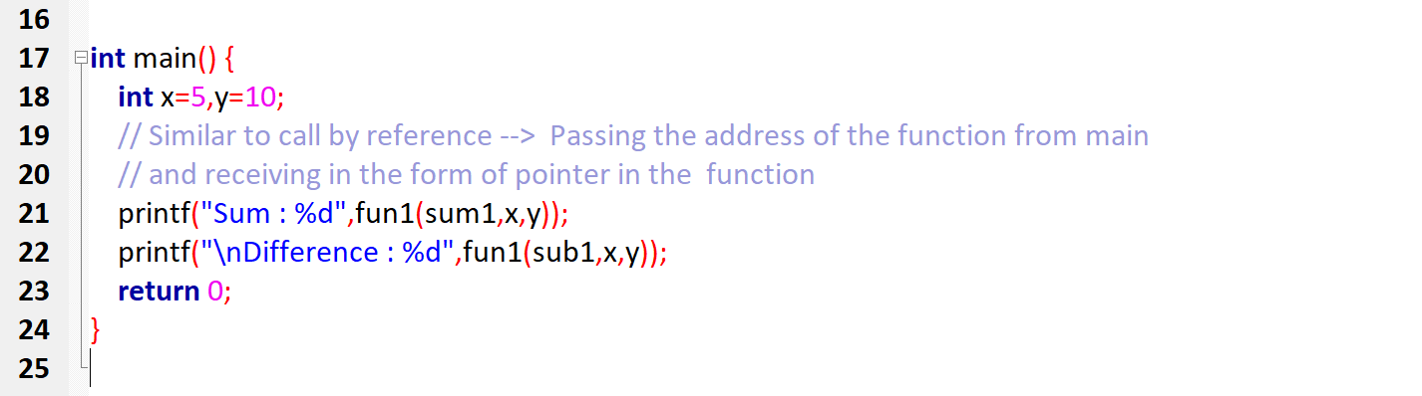

Output

